Student Task Manager – ISE-2 Evidence

Student Name: Amruta Karande
Project Name: Student Task Manager
Technologies Used: HTML, CSS, JavaScript, Git, GitHub, Jenkins
- Website Screenshots
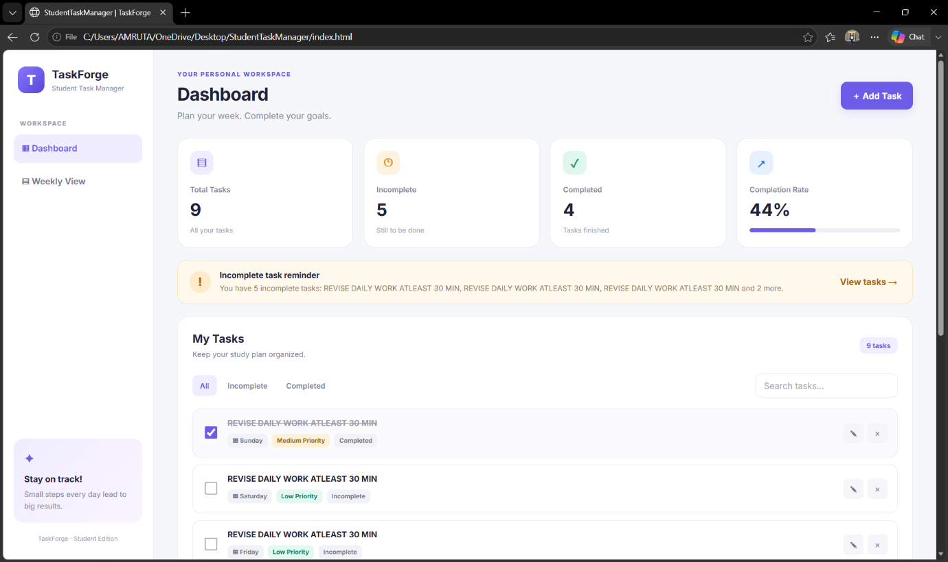
- Add Task
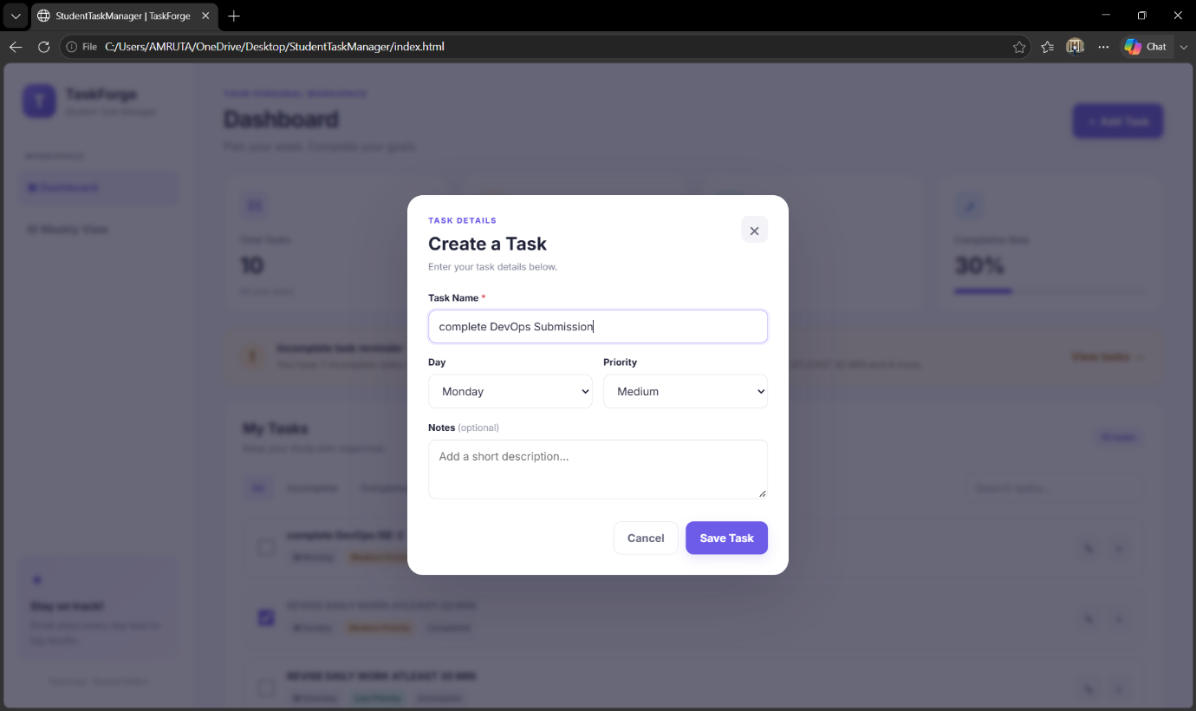

- Task Completion And Weekly View
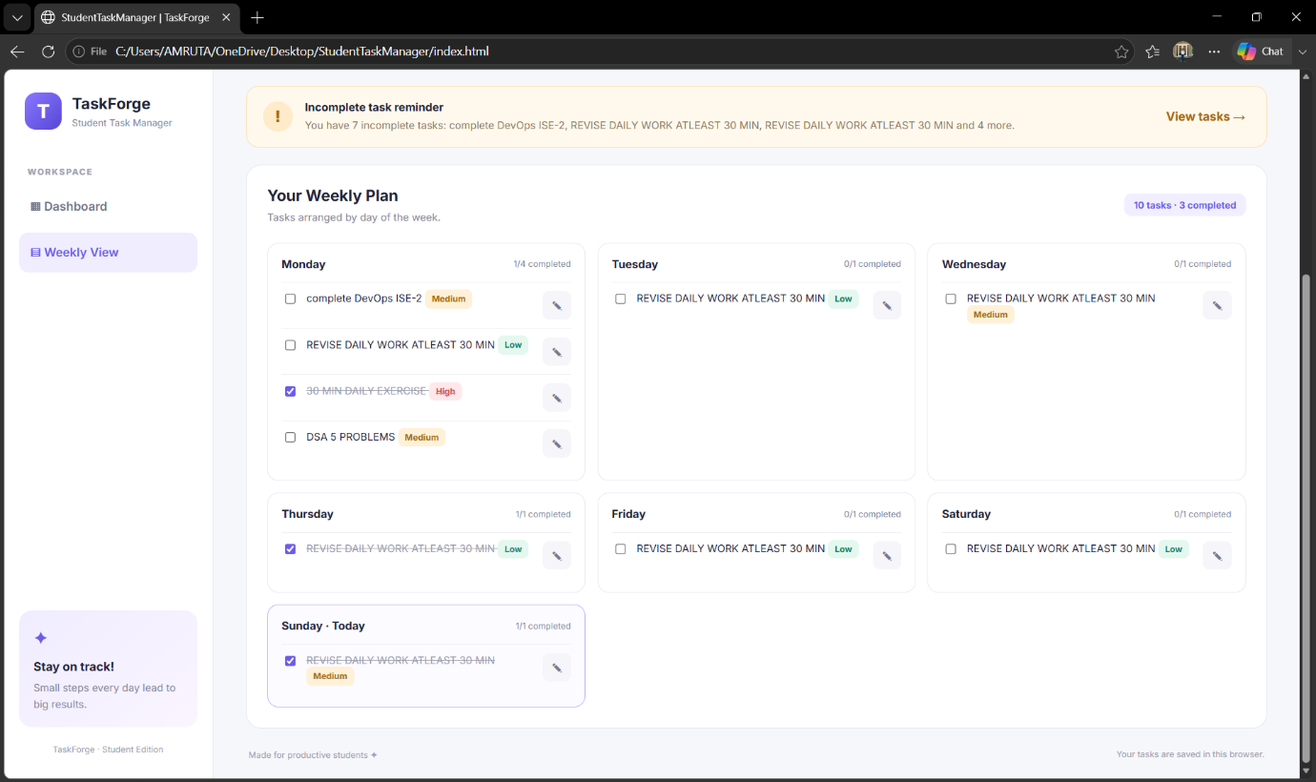

- GitHub Repository

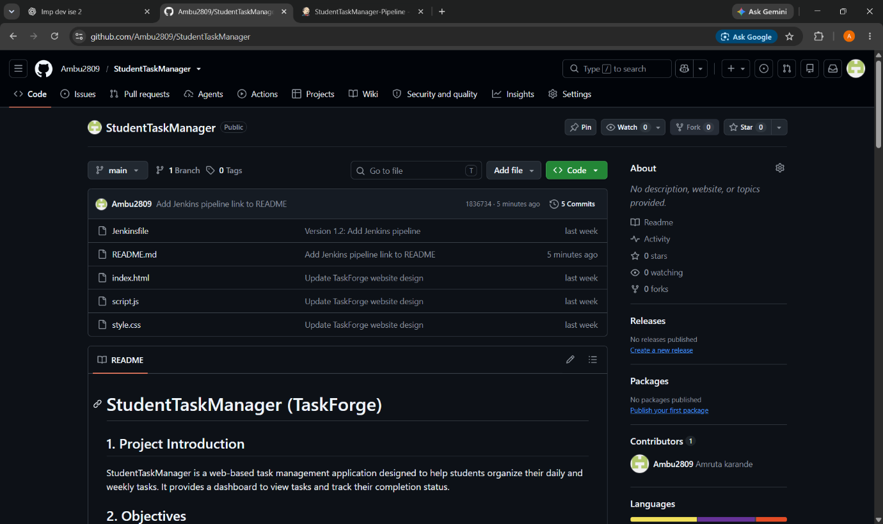

- Git Commit History

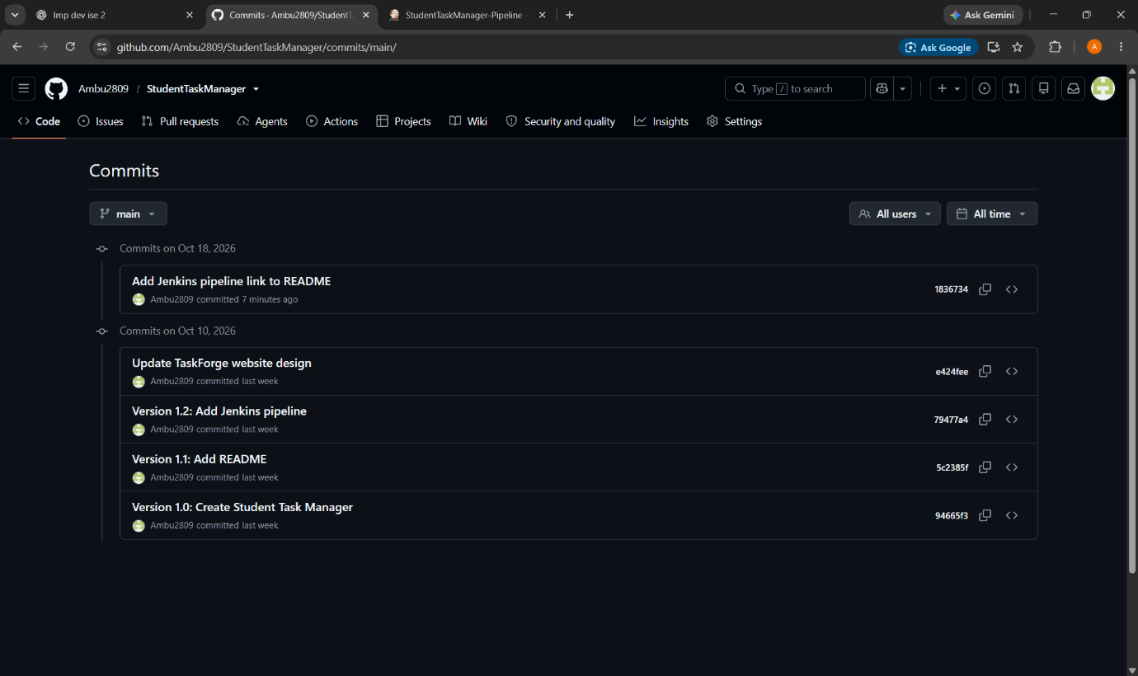

- Jenkins Successful Build

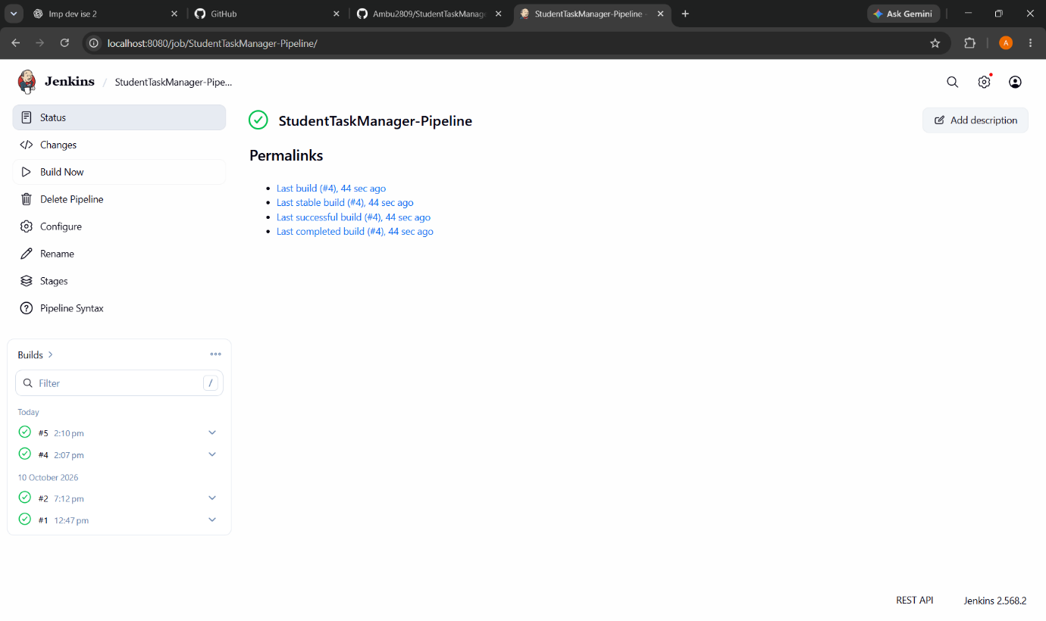

5. Jenkins Console Output
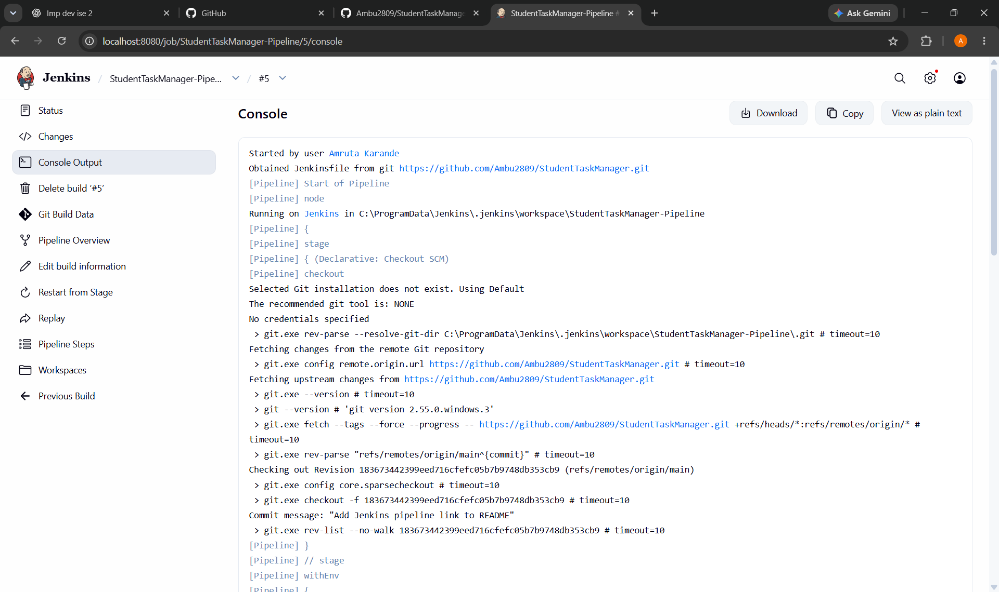

- Jenkins Pipeline Status / Stages
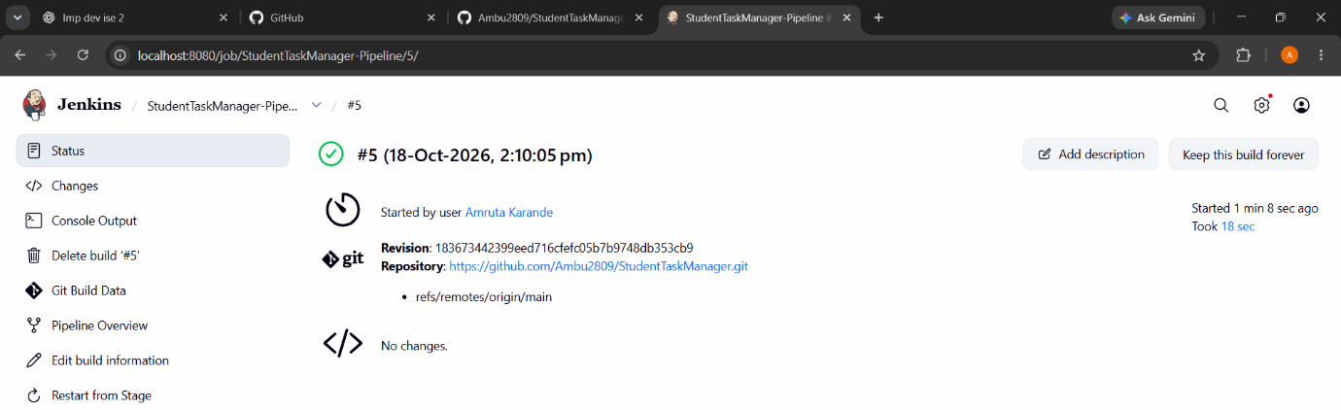

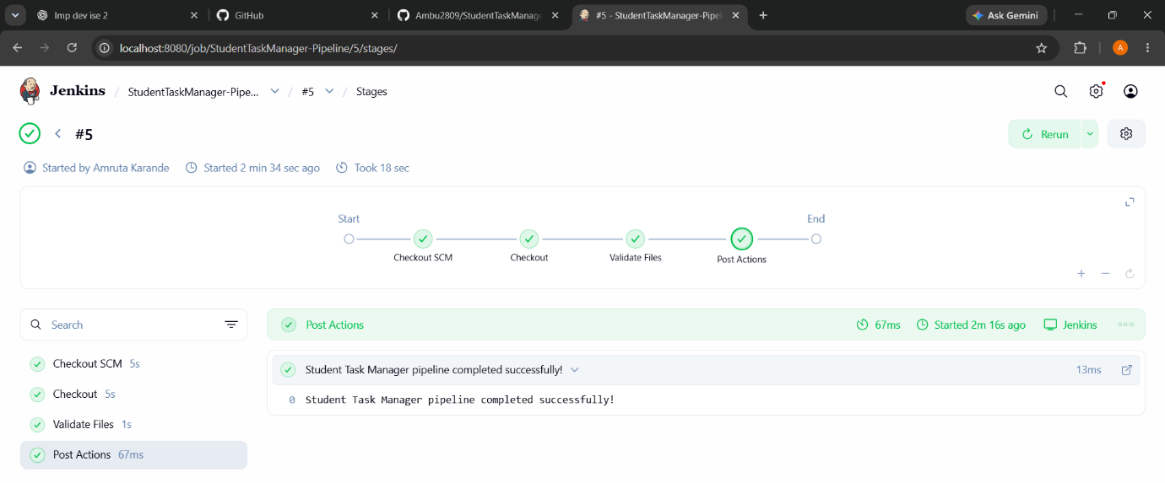
Conclusion
The Student Task Manager project was maintained using Git and GitHub. Jenkins was integrated to run the pipeline and verify the project workflow. Screenshots are included as evidence of the implementation.

